**Nexelus 12.8**

Following changes will be part of Nexleus 12.8 (Exact version will be decided later).

1. Multi Tabbing Across application.
   1. We allowed users to use multi tabs for media plans (in Nexelus 12.5) which will allow users to use different media plans in different tabs within single session simultaneously.  
      We have to provide same feature across all application to allow users to use same user interface in multiple tabs.  
      **Please estimate Setup and Administration UI Separately.**
2. Moving from AdWords API to Google Ads for budget order and delivery.  
     
   Nexelus has integration with Google Ads (aka AdWords) which allows Nexelus to create budget orders and pull invoice/ Performance data from Google Ads. Currently Nexelus is using “**AdWords APIs**” for this integration.

Google has developed new enhanced API’s “Google Ads API” for Google Ads integration which will eventually overtake “**AdWords API**”**,** currently Google didn’t sunset old API (AdWords being used by Nexelus). However, they are now actively working on new APIs “**Google Ads**”. That’s why we need to move our integration from “**AdWords API**” to “**Google Ads**” API. We have already done it Invoices and will have to do it for Budget Order creation and Performance data pull.  
  
<https://developers.google.com/google-ads/api/docs/release-notes>

1. Conversion of eConnect application to .Net.
   1. Currently we are using VB 6 DLL for eConnect integration, we need to migrate Vb6 code to .net code to lower the maintenance and deployment cost.
2. Enhancement in DCM errors and style coming from DCM.  
   Nexelus has integration with DCM (Double-Click campaign Manager) which allows Nexelus to push DCM plan to DCM. Currently, Nexelus is displaying error message coming back from DCM as it is in case if there is any error during sync. However, that error is not very user friendly.  
   With this change Nexelus will override DCM errors with more meaningful errors before displaying it to users using the error code coming from DCM. We should also have ability to show raw text from DCM.
3. Import / Export without MS Excel.  
   Nexelus provide data import/ export using MS Excel from multiple places. Nexelus is currently using MS Office objects to data import/ export which requires MS office installation on Web Server which is additional overhead and comparatively unsaved for web server to have office installed on it.  
   With this change Nexelus will use 3rd party library for Import/Export which doesn’t require MS Office installation on web server.
4. Individual Placement Save is still slow, needs to optimize individual update process.  
     
   Updating individual vendor placement under media plan module is very slow, we need to enhance its performance in every case (with multiple UDS and Naming convention enabled).
5. Display prompt if user enters delivery at package level when Rule is set to override at placement level.  
     
   Nexleus has company rules which allow users to define if they want to provide delivery information at the package level or at the placement level in delivery import bulk-sheet.  
   Currently, if rule is set to provide delivery at package level and user mistakenly enters delivery at placement level, system ignores entered delivery at all. With this change Nexelus is display a warning message if user has entered delivery at the wrong (entered at package if rule was at placement and vice versa) location for any placement to option to review data before importing.  
      
   Please note that this will be just a warning message not the restriction. We will finalize message text later.
6. External File storage (AWS and MS One Drive (Testing only)).

Nexelus provides an option to configure Nexelus with cloud platform for document management. Currently Nexelus is integrated only with Google Docs  
With this change Nexelus will add additional integration with MS one drive and AWS (S3) for document management which will provide multiple options for user to choose from for Cloud document management if user wants to use Cloud for document management.  
Please note , that only single integration can be enabled for single Nexelus instance.  
  
  
  
Following Items will be part of Next version as well but it requires further details which will be provided by Dec 15th.

1. Media: Optimization.

1. Integration with DOCU SIGN.
2. Transfer functionality for inter-company on owner side.
3. Ability setup revenue schedule for the entire project length by period.
4. Possibility of filtering IO's based on month of service Or display IO dates at IO header level.
5. Can we still use “Media Paid by Client” at the Nexelus Campaign level? If a Client team isn’t going to use the Client-level Vendor settings, if ALL Media and Ad tech are going to be paid by client or not, this still seems like an efficient way to set that than having to go Vendor by Vendor or Media Plan by Media Plan. But I don’t understand how this would interact with the client-level settings and media plan level settings. It’s getting a bit confusing… [AN: Media paid by client can be set at Project level and will default to all Media plans under it. One can override it on Media plan level. The setting on Project is under Media tab. AdTech paid by client is not available on Project/Campaign] [NL 1/8/21: So if this is checked and there are Vendors NOT set up as Paid by Client at the Client Profile level, all Vendors would be Paid by Client (meaning the Project/Campaign setting is trumping the “nothing” set at the Client-profile level)? But if this is unchecked, and there are Vendors set up as Paid by Client at the Client Profile level, the Vendors would be Paid by Client (meaning the Client-level setting is trumping this Project/Campaign setting)? For the record, I find it confusing that the trumping isn’t ALWAYS Media Plan trumps Campaign trumps Client, where we can set each level as Paid by Client or Paid by Agency] [AN: Yes your understating is correct. Current design doesn’t allow to
   * 1. undo ‘Media paid by vendor’ if a vendor is set at client profile level
     2. Mark a vendor as Paid by client on Media plan level. It always defaults from client profile]
6. Date bug in delivery override

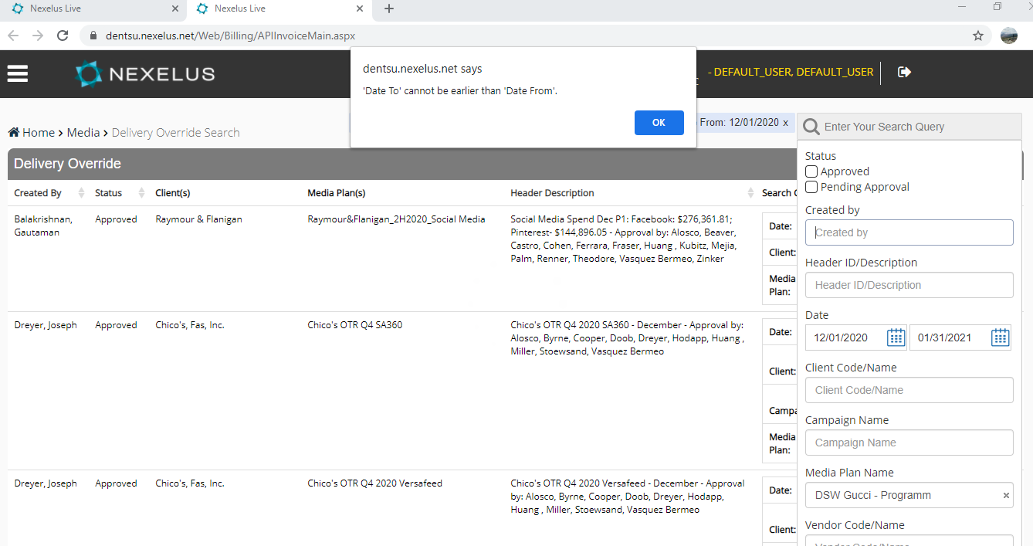

1. Display full client name on Campaign and Media plan search screens. We do have space so we should expand the name. Also show tooltip if it exceeds the new increased length.

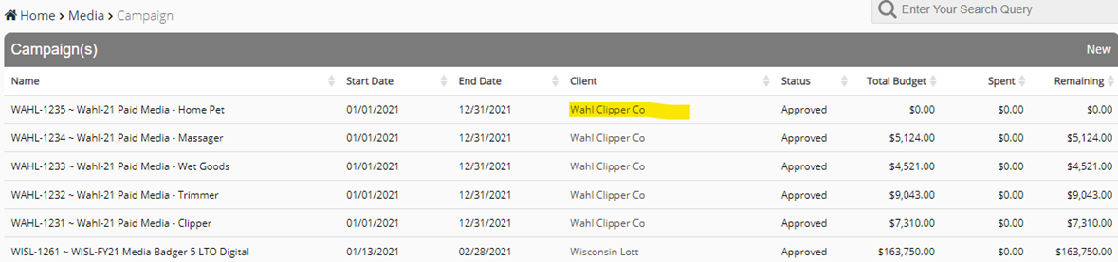

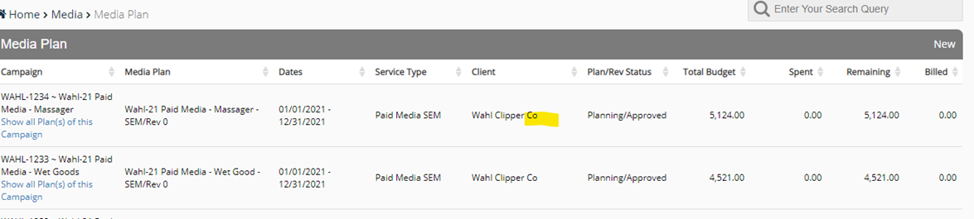

1. Wild card search for Media Plan on Prebill
2. Wild card search for Media Plan on Delivery Override
3. RE: API Sunset – Upgrade before feb 28